# TCES 455, Autumn 2016

# Laboratory 3: DC Water Tank Level Control

### Objective

The objective of this laboratory exercise is to develop a simple feedback system that regulates the water level in a tank. Refer to Figure 1, below.

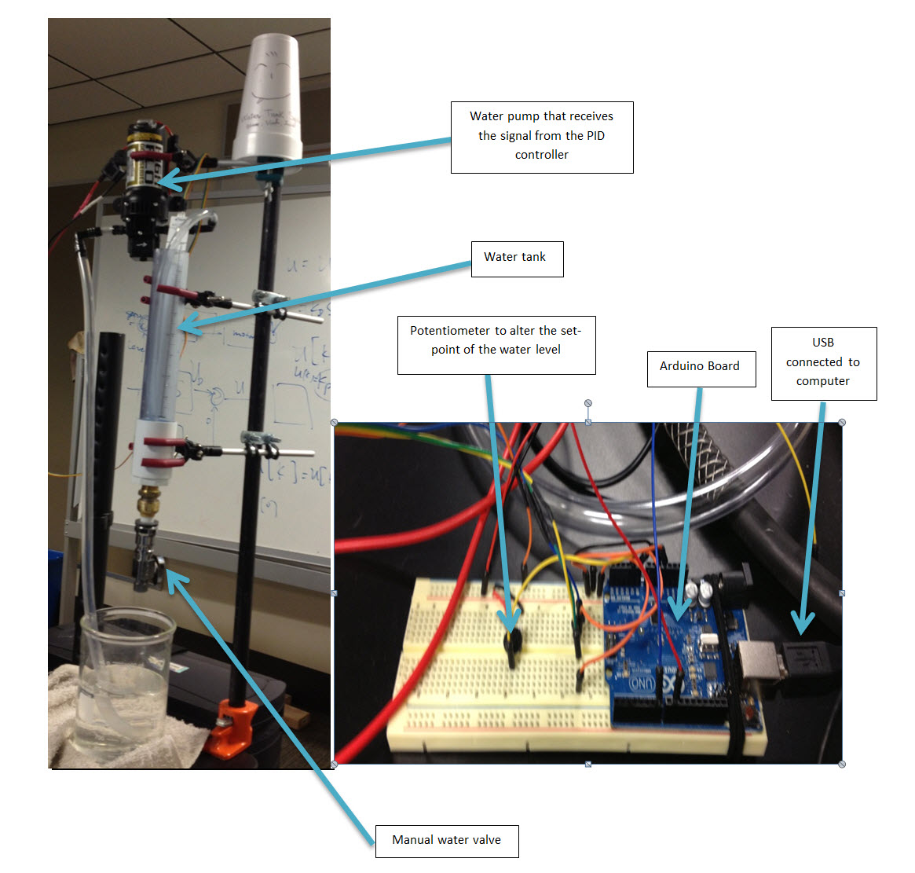

Figure . The Setup (Photos by Phan, Mertens, and Mackey)

During normal operation, the valve at the bottom of the tank is open and the control system controls the speed of the pump, which, in turn, controls the rate of flow into the tank. The tank level is measured by a pressure sensitive tape which changes resistance as the water level changes. A potentiometer allows the user to change the water level set point.

For this lab you will be turning in your final code that you used for this lab INDIVIDUALLY, you will be working as a group but you each need to turn in your code. If you do not turn in your code you will not receive any credit for this lab.

All code MUST be written from scratch, you will not be able to use any of the libraries or other modules and shortcuts available, that comes later.

Also, each person needs to complete the group evaluation form. If you decide to just give everyone full credit even if they do not deserve it, I will know and both of you will receive a zero. It’s ok to give full credit when it’s due, the results of the group grades will be made public after the final project is complete. I will speak to anyone receiving poor grade from the groups in such a manner that will preserve the anonymity of the graders.

### Theory of Operation

Figure 2 depicts an ideal water tank.

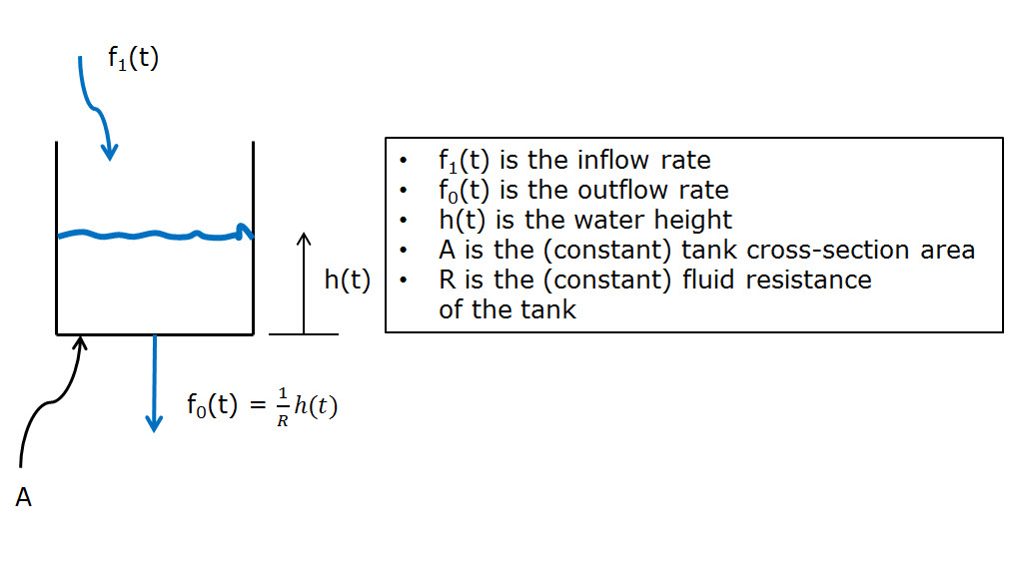

Figure . Ideal Tank

We found the governing differential equation to be

$$A\frac{dh(t)}{dt}+\frac{1}{R}h\left(t\right)=f_{1}(t)$$

which is equivalent to the transfer function

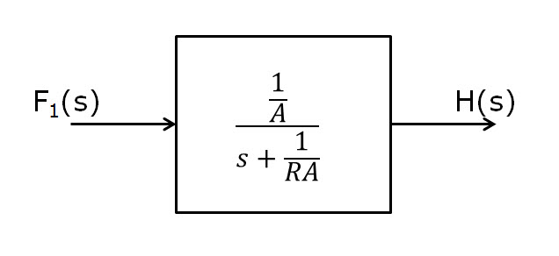

Figure . Ideal Tank Transfer Function

Call this transfer function T(s).

Our control system block diagram will look like Figure 3. For this lab we will only be concerned with the part in the RED box, the PID will come later.

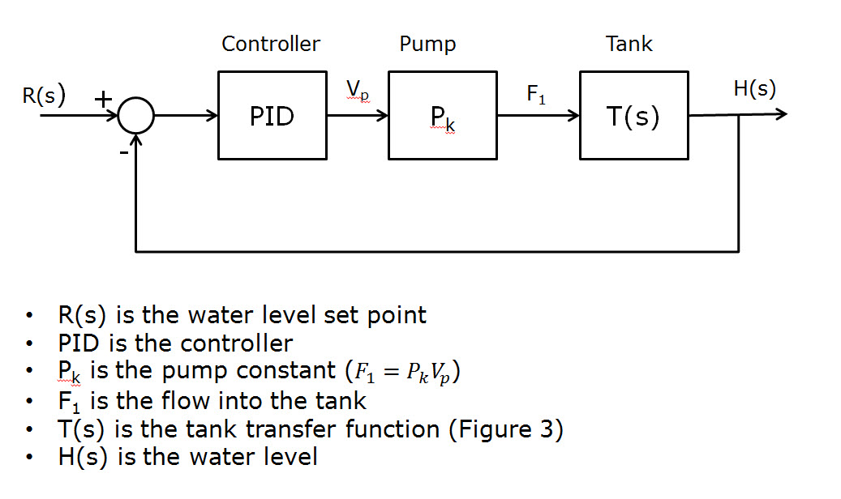

Figure . Closed Loop System

### Simulation

You will have to measure or set up tests to measure (I would suggest making sketches for some of these as you will be doing this again):

* The tank cross sectional area, A
* The fluid resistance, R
* The pump constant Pk

### Implementation

Use your Arduino to implement this control system. Use timer/counter 3 to cause your controller to run at exact times (say, 10 times per second). This will give you a precise ∆t to use in your calculations. Use the coefficients you found by simulation as starting points and adjust as necessary to achieve a good level controller.

Use a potentiometer as shown in Figure 1 to adjust the set point.

### The Notebook

Individually, write in your laboratory notebook everything that describes what you have done here. It should contain

* A title
* The names of the people in your group
* The objective
* The measurements and tests you did to find any necessary constants for the transfer functions (you can include your tape measurements in this part).
* The theory of operation (in your words)
* The simulation (graphs, figures, all of your results, and a discussion covering why you chose the particular controller you came up with)
* The implementation
  + A detailed list of all the hardware you used
  + A detailed block diagram showing units conversions, etc.
  + A discussion of the results of all your testing (how did the system behave with the constants you found by simulation, what did you change to get better results)
* Conclusions should concentrate on differences in behavior between simulation and implementation. Include anything else you found interesting.
* Appendix should include your final Arduino sketch.